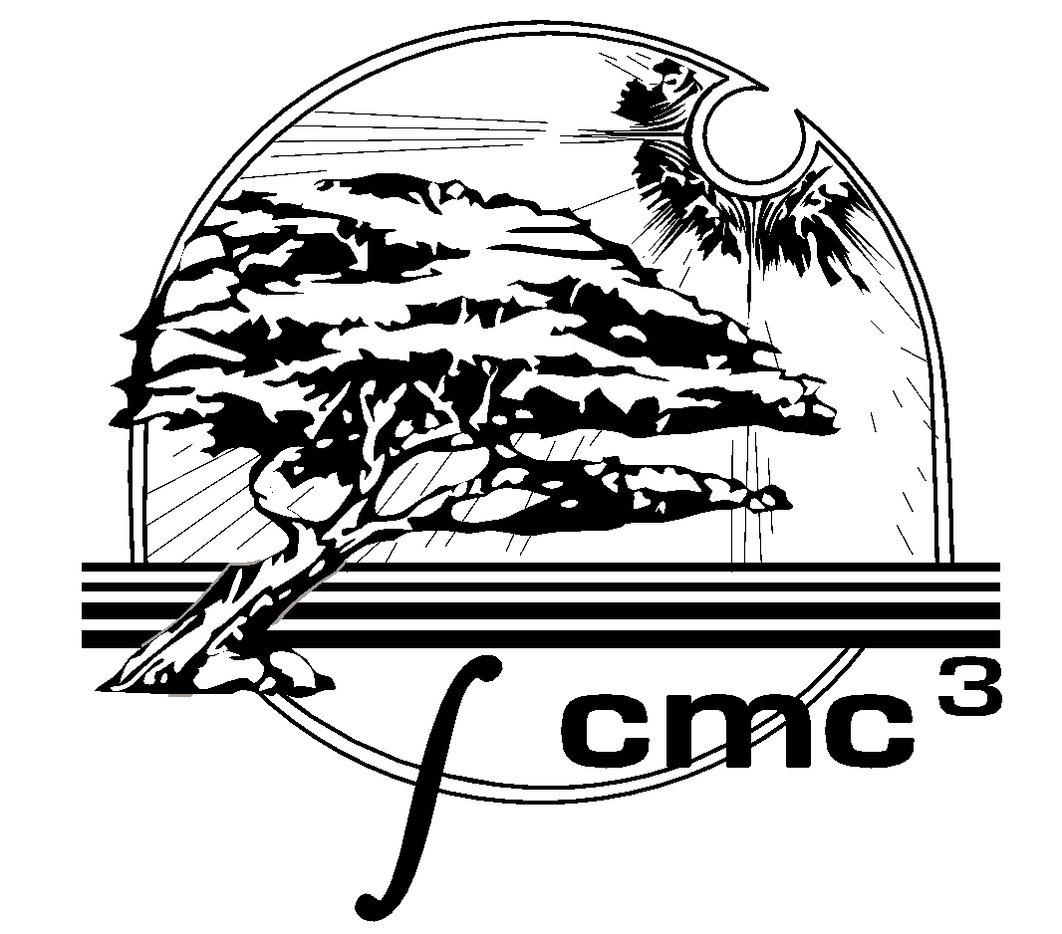

2024 Student presentation Contest

**The Details**

**What**: Create a poster to display live, or a 5 minute video presentation to submit virtually, with the help of a Faculty Mentor

**Why**: To explore an exciting topic in Mathematics, Mathematics Education, or Mathematics History

**When**: Bring your poster to Monterey to display **Saturday November 2,** or if participating remotely, have your video ready to share by **Wednesday October 30**

**Where**: You can participate remotely or in person! In person at Solano Community College, or remotely by creating and sharing a video.

Are you an active student at a CMC3 member college?  
(Ask your math instructor to check)

# Explore an exciting topic in Mathematics or Mathematics History with a Faculty Mentor!

Faculty Mentor must be a member of CMC3

Cash Scholarships up to $300 will be awarded!

See <http://cmc3.org/students/posters/> or scan QR code below for more information

